For passenger cars, “JEEPs”, VANs,“pick-up” or light trucks (Light Commercial Vehicles), Power Generators & Earth Moving Equipment
Fuel Usage and Fuel Consumption Monitoring Brief:
Fuel (Gas) pricing growing and growing and reaching record levels.
Yours vehicle fleet (special machinery) require more and more money on fuel costs. Your earnings slowly, but steadily declining.

You do not have the opportunity to influence the growth of fuel prices, but to reduce the cost of fuel consumption is in your best.
This decision is quite simple: full control over the use of your fuel and lower transaction costs than the rational use of fuels.

Vehicle monitoring
TracknSecure vehicle monitoring platform allows you to track and operate your fleet 24/7. You just need to login to our system from any computer with internet using your given password and you can check the vital info. Such as:
* position of your vehicle
* route history
* work time
* fuel consumption
* fuel level in the tank
* many other data displayed in various reports and diagrams
What is more, system can inform you when your vehicle arrives into destination point of the chosen area, and give you information about low battery, speeding, fuel theft, temperature changes etc.
Mentioned functions allow you to concentrate on other things and react only when problem is noticed.
Top quality maps allow us to provide services all around the world, wherever your business takes place.
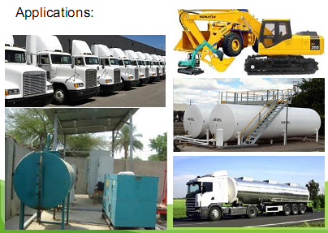

Fuel consumption

With an assistance of our system you can control your fuel easier then ever. That lets you cut a huge share of your business costs off. We give you the opportunity to monitor both of the most important readings:
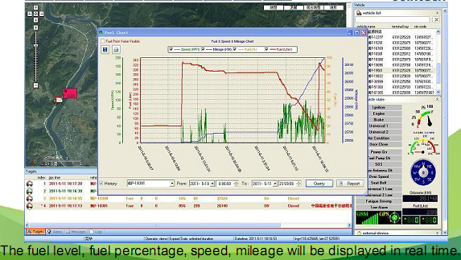
TracknSecure system allows you to monitor fuel usage and disclose fuel thefts. That improves the efficiency of your fleet. By comparing both fuel level in the tank and fuel consumption, you can achieve most reliable and secure numbers.
Total distance | Fuel consumption (ltr /100 km)
301.75 | 34.80
The system will give you graphs for the chosen travel period. There you will see fuel consumption, fuel-level variation, refillings, drains, exact amounts of it and specific locations where it happened. The system can report such incidents by alarm or by instant SMS according to your wish.
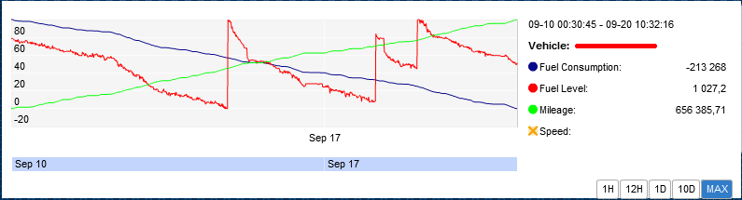
Possibility to get fuel consumption from board computer directly depends on the vehicle. We are able to get that data from most of the new trucks and popular light cars. Otherwise, we can offer alternative techniques for fuel consumption.
Additional Features
We understand that every client is an individual, therefore, we always adapt solution according to our client's needs. For this we use following peripherals:
* temperature sensors;
* door/trailer sensors;
* digital fuel meters;
* panic buttons;
* driver ID sensors;
* and many other.
Moreover, our system can be used for people tracking. We achieved that by using compact GPS device that you can simply put in your pocket or purse.

HARDWARE, & INSTALLATION COST FOR REALTIME ONLINE TRACKING & FUEL MONITORING SYSTEM

Commercial Proposal Per Single Fuel Tank Equipment/Truck:
GPS/GPRS Telematic Hardware: $350
Fuel Sensor: $200
Quarterly GPRS COST: $100
Quarterly Online Software Subscription: $100

TOTAL COST $750

Commercial Proposal Per Double Fuel Tank Equipment/Truck:
GPS/GPRS Telematic Hardware: $400
Fuel Sensor: $400
Quarterly GPRS COST: $100
Quarterly Online Software Subscription: $100

TOTAL COST: $1,000

