Alternative Energy Solutions for Home & Office

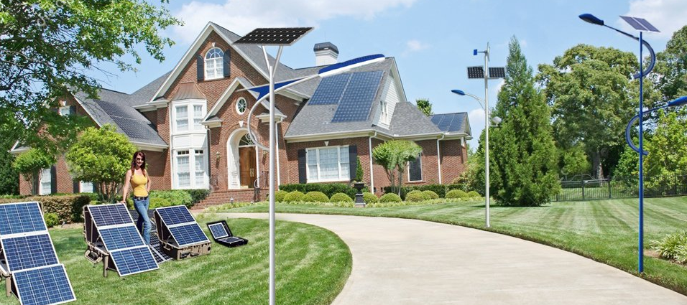

Solar Powered 1.0 – 3HP Air-Conditioners
24hrs Continuous Cooling for Your Homes & Offices without need for Utility Electricity
Other products available: Solar Refridgerator, Deep Freezers, Solar Home Lighting Systems, Solar Water Pumps

High Efficiency 100% Solar Powered Air Conditioner for Homes, Offices, Hotels, Schools, Restaurants, Churches etc.
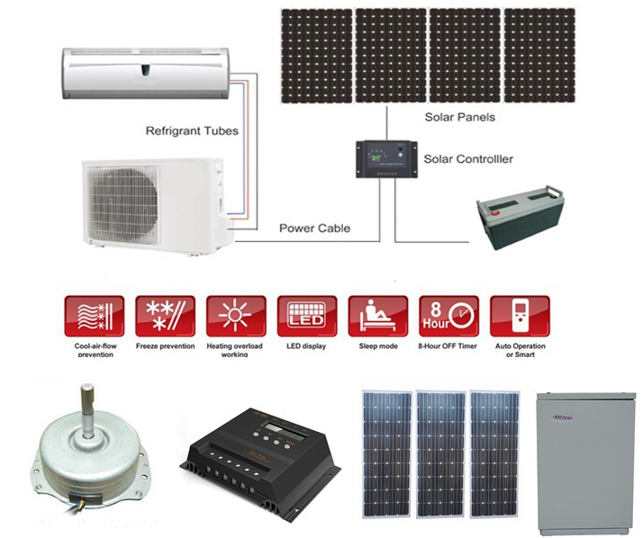DC VFT Solution
In addition to avoiding the cost and power loss of an inverter, our system is engineered from the ground up for use with solar. Special electronics anticipate and smoothly handle voltage fluctuations of up to 38% without affecting the operation. In addition to the compressor and control circuits, all other electrical components are DC powered including high efficiency DC fan motors, DC valves & solenoids, etc. There are no inverters used inside the system.
The brushless DC compressor and fan motors we use provide a "soft-start" which means that the typical startup surge of an AC air conditioner running on an inverter is eliminated. A normal air conditioner will draw up to 500% more amps on startup, meaning that when running on an inverter, the inverter must be oversized accordingly. Oversized inverters are much less efficient. The DC motors and controls used in the DC48VFT-12 system not only avoid needing an inverter, they also minimize the surge or spike at time of startup.

DC VFT Compressor
The system uses a VFT (Variable Frequency Technology) controller and frequency driver in conjunction with multiple sensors and an algorithmic control circuit to raise and lower the units capacity in real time based on conditions as they change. The VFT controller manages the compressor speed, refrigerant flow, fan speed, etc., which can all be precisely matched to the immediate cooling requirements. As the set-point is closely approached, the system will lower its capacity and power consumption, running at a very low energy draw as needed to maintain proper temperature rather than overshooting the set-point and then cycling on and off like a standard air conditioner. Not including the avoided DC to AC to DC power conversion losses, the VFT feature alone saves 30-40% compared to a standard air conditioner.
The DC48VFT-12 air conditioner uses a neodymium permanent-magnet Brushless Direct Current (BLDC) hermetically sealed motor and compressor with high performance windings, similar to the technology used in the worlds highest efficiency air conditioners. This particular compressor is made for us by the same manufacturer that makes high efficiency compressors.

Specifications
1.100% energy save by using pure solar power
2.no need any electricity
3.CE,ISO9001,CCC approved
12000BTU High Efficiency 48V DC air conditioner features:
*48V DC power driven, no inverter required, no AC power required.
* Deep cycle batteries as energy bank for overnight operation
*.Intelligent Defrost, Independent Dehumidification, Sleep Mode, Quiet Operation;
*.Auto—protection, Auto Restart;
*.Sleeping Model, Remote Control
* Hi-SEER Brushless inverter DC permanent magnet compressors
* DC brushless indoor and outdoor fan motors
* R134a CFC free refrigerant, Eco-friendly
* Minimum energy loss, EER>19
* Short investment return period (3 years)
* Off-grid mode, 100% driven by solar energy, 100% energy saving
* Solar- mains power (110V/220V) hybrid mode available.
* operation time/day choices:8hours 12hours 16hours 24hours
* Certificated by CE and ISO9001
* Capacity choices:9000btu 12000btu 18000btu 24000btu
Power Supply:48VDC (44V to 54 V)
Model No. |  |  | TKF-26GW/DC | TKFR-35GW/DC | TKFR-50GW/DC | TKF-72GW/DC
Performance
Capacity | Cooling | Btu/h | 9000 | 12000 | 18000 | 24000
 |  | W | 2600 | 3500 | 4300 | 7200
 | Heating | Btu/h | 10000 | 13000 | 18000 | 27000+1700
 |  | W | 2800 | 3700 | 4800 | 7900+500
Noise | Indoor | dB(A) | ≤40 | ≤42 | ≤43 | ≤50
 | Outdoor | dB(A) | ≤50 | ≤52 | ≤54 | ≤58
Air Circulation |  | m³/h | 450 | 550 | 650 | 1050
Suitable Area |  | m² | 10~15 | 12~25 | 20~30 | 30~48
EER |  | W/W | 4.56 | 3.89 | 3.91 | 4.80
 |  | Btu/h/w | 15.79 | 13.33 | 16.36 | 16.00
Refrigerant |  |  | R-134A
Compressor |  | DC 48V
Power Consumption
Power Input |  | W | 570 | 900 | 1100 | 1500
Rated Current |  | A | 11.5 | 16 | 22 | 50
Input Power |  | V | DC 48 | DC 48 | DC 48 | DC 48
Dimension
Indoor Unit | NET | mm | 745*255*195 | 775*260*210 | 1070*385*265 | 1070*385*265
 | Shipping | mm | 780*240*305 | 840*325*265 | 1100*400*285 | 1100*400*285
Outdoor Unit | NET | mm | 645*245*495 | 790*260*540 | 790*260*540 | 790*260*540
 | Shipping | mm | 725*320*540 | 910*370*610 | 910*370*610 | 910*370*610
Weight
Indoor Unit | Net/Gross | kg | 9/10.5 | 11/13 | 12/15 | 15/17
Outdoor Unit | Net/Gross | kg | 35/36 | 38/40 | 43/45 | 48/52

Power Supply：48VDC (44V to 54 V) for 14 hours backup at night
Model No. |  |  | TKF-26GW/DC |  | TKFR-35GW/DC |  | TKFR-50GW/DC | TKF-72GW/DC
 |  |  | 1HP |  | 1.5HP |  | 2HP | 3HP
Performance
Capacity | Cooling | Btu/h | 9000 |  | 12000 |  | 18000 | 24000
 |  | W | 2600 |  | 3500 |  | 4300 | 7200
 | Heating | Btu/h | 10000 |  | 13000 |  | 18000 | 27000+1700
 |  | W | 2800 |  | 3700 |  | 4800 | 7900+500
Noise | Indoor | dB(A) | ≤40 |  | ≤42 |  | ≤43 | ≤50
 | Outdoor | dB(A) | ≤50 |  | ≤52 |  | ≤54 | ≤58
Air Circulation |  | m³/h | 450 |  | 550 |  | 650 | 1050
Suitable Area |  | m² | 10~15 |  | 12~25 |  | 20~30 | 30~48
EER |  | W/W | 4.56 |  | 3.89 |  | 3.91 | 4.80
 |  | Btu/h/w | 15.79 |  | 13.33 |  | 16.36 | 16.00
Refrigerant |  |  | R-134A |  | R-134A |  | R-134A | R-134A
Compressor |  | DC 48V | DC 48V |  | DC 48V |  | DC 48V | DC 48V
Operation Temp. |  | ℃ | 17-30 |  | 17-30 |  | 17-30 | 17-30
Power Consumption
Power Input |  | W | 570 |  | 900 |  | 1100 | 1500
Rated Current |  | A | 11.5 |  | 16 |  | 22 | 50
Input Power |  | V | DC 48 |  | DC 48 |  | DC 48 | DC 48
Dimension
Indoor Unit | NET | mm | 745*255*195 | 775*260*210 |  | 1070*385*265 |  | 1070*385*265
 | Shipping | mm | 780*240*305 | 840*325*265 |  | 1100*400*285 |  | 1100*400*285
Outdoor Unit | NET | mm | 645*245*495 | 790*260*540 |  | 790*260*540 |  | 790*260*540
 | Shipping | mm | 725*320*540 | 910*370*610 |  | 910*370*610 |  | 910*370*610
Weight
Indoor Unit | Net/Gross | kg | 11/13 | 13/15 |  | 15/17 |  | 15/17
Outdoor Unit | Net/Gross | kg | 38/40 | 45/48 |  | 48/52 |  | 48/52
48V DC Air Conditioner FOB Lagos Price
Cooling Only | FOB Lagos | USD | US$2,300.00 | US$2,600.00 |  | US$2,900.00 |  | US$3,350.00

Backup System Price FOB Lagos Optional
working time:12-14hours | Solar panel：150W*4 | Solar panel：150W*6 | Solar panel：150W*8 | Solar panel：150W*10
 | Solar controller: 48V20A | Solar controller: 48V30A | Solar controller: 48V40A | Solar controller: 48V40A
 | Batteries：12V65Ah*4 | Batteries：12V100Ah*4 | Batteries：12V150Ah*4 | Batteries：12V150Ah*4
Backup System Value/USD | US$2,500.00 | US$2,800.00 | US$3,270.00 | US$4,000.00

1.All above prices with term of FOB LAGOS
2.Delivery: Deliver all goods in 60 days after receipt of down payment
by the buyer.
3.Payment: by 100% in advance before shipment.
Warranty: 5 years for compressor, 3 years for whole unit.
4.MOQ: 2 units per model; sample price should higher of 15% than MOQ.
5.Validity: within 4 weeks
6. Prices excludes delivery to client location and installation cost.

Scotia World Ltd.
Email :-james.sharp@scotia-world.com
Tele :- 0044 141 416 0200 UK - International.
Scotia Nigeria Limited,
37 Bimkol Cres, GRA2,
Port Harcourt,
River State.
Nigeria.
Nigerian GSM +234 818 315 2433 Scotia Nigeria Ltd.
+234 703 284 5561 Scotia Nigeria Ltd.
+234 818 360 5335 Scotia Nigeria Ltd.

